[Anime] Site Plan

[Zeta Cruz]

WDD 130

Overview

Purpose
"My website is a personal anime showcase designed to highlight the series that have shaped my interests. Many anime sites try to cover everything; mine solves the problem of information overload by offering a focused, curated space built around what I genuinely enjoy. As a web design student and lifelong anime fan, I’m uniquely positioned to create this kind of tailored experience. The site stays simple and high‑level, presenting each show with clear explanations of why it matters to me. It’s concrete, easy to navigate, and customized for anyone who wants honest, personal recommendations rather than generic lists. My goal is to spark curiosity and start conversations about the stories that inspire me." - MS Copilot

Audience
My audience will consist of students and faculty within WDD130 class. Other than that, my audience also includes people who are curious about anime in general.

Branding

Website Logo

Style Guide

Color Palette
Primary | Secondary | Accent 1 | Accent 2
#A45642 | #FBF2E7 | #DEA64F | #443C34
Accent 2 seems good for text.

Typography (links for html doc)

Heading Font: [Jaro]

Paragraph Font: [Fira Sans]

<link rel="preconnect" href="https://fonts.googleapis.com">

<link rel="preconnect" href="https://fonts.gstatic.com" crossorigin>

<link href="https://fonts.googleapis.com/css2?family=Fira+Sans:ital,wght@0,100;0,200;0,300;0,400;0,500;0,600;0,700;0,800;0,900;1,100;1,200;1,300;1,400;1,500;1,600;1,700;1,800;1,900&family=Jaro:opsz@6..72&display=swap" rel="stylesheet">

(these links are for the html)

Navigation
Home Anime Misc

Content
[ Home Page: ]
“What is this Site?”: Welcome to the My Favourite Anime website! If you are sick of the same-old battle shounen action formula and want to explore other genres of anime but don’t know where to start, this place is for you! Browse a limited selection of shows & comics, and find for yourself a new series to binge in your free time!
“What is Anime?”: Literally speaking, the term “anime” refers to any work of animation. Though in the lingo of American watchers, it specifically refers to any work of animation within Japan. Anime are usually, though not always, adaptations of japanese comics called “manga.”
“What is Misc?”: Shortened from the word miscellaneous, the “misc” page of this website is consisting of recommendations of shows or series that aren’t strictly anime, whether they be comics, cartoons or books.

[ Anime Page: ]
[About] “What is this?”: This is my page focused solely on my anime recommendations! Literally speaking, the term “anime” refers to any work of animation. Though in the lingo of American watchers, it specifically refers to any work of animation within Japan. Anime are usually, though not always, adaptations of Japanese comics called “manga.”

Frieren: Beyond Journey’s End (2023): Currently airing with two seasons, this anime is the current gold-standard for how great anime can be. This series is about the titular immortal elf Frieren, a former member of “The Hero’s Party,” who had vanquished the Demon King and his army 80 years prior to the events of the story. After the death of the beloved hero Himmel, Frieren sets on a journey to the land of the dead along with the current disciples of her former party-members. Both dubbed and subtitled in English, this series is a slow-burn, cozy fantasy anime about living in the moment and appreciating the small things in life. Coupled with good writing and excellent animation, Frieren: Beyond Journey’s End is a great place to start watching anime. This anime is adapted from a manga of the same name, which has been in hiatus since October 2025.
Genre: fantasy, magic, adventure, slice-of-life, drama, slow-pace

Trigun (1998): A completed full season consisting of 26 episodes, Trigun ‘98 follows Vash the Stampede. Explore the travels of a pacifist gunman wandering the dog-eat-dog planet of No Man’s Land, also called Gunsmoke depending of what version is being watched. Both dubbed and subtitled for English fans, this series starts off as an episodic space-western sci-fi, and evolves into high-stakes drama as the series goes on. This anime is adapted from a manga of the same name, albeit very loosely. There are other iterations of this work, all exploring different story-lines concerning the protagonist Vash the Stampede. If old-school isn’t your style, there’s also the on-going reboots of Trigun Stampede (2023) & its sequel series Trigun Stargaze (2026).
Genre: space-western, sci-fi, action, comedy, post-apocalypse, drama

Yona of the Dawn (2014): Airing in 2014, Yona of the Dawn begins as a cheesy period romance about a spoiled rich girl. Do not be fooled by this initial front, however, as it quickly reveals itself to be a emotional tale of political intrigue, as the sheltered princess Yona and her guard Hak must flee the castle after a coup & attempt on her life. Now, she must reinvent herself from a whiny, sheltered princess into the courageous leader of an ensemble of prophetic warriors & revolutionaries. This anime is very faithfully adapted from a manga of the same name, and is recommended for fans of emotional story-telling coupled with excellently-paced action.
Genre: coming-of-age, action, adventure, romance, historical drama, politics

[ Misc Page: ]
[About] “What is this?”: Are you sick of anime in general but still want something to read or watch? Well, you’re in luck because I also have non-anime recommendations for series! Shortened from the word miscellaneous, the “misc” page of this website is consisting of recommendations of shows or series that aren’t strictly anime, whether they be comics, cartoons or books.

Toilet-Bound Hanako-Kun: Despite its name, this series is one of the greats. This comic series is recommended for those looking for a visually stunning action/adventure series, that soon evolves into a heart-wrenching drama with a large cast of complex characters. Written and drawn by the acclaimed AidaIro duo, Toilet-Bound Hanako-Kun is about high schooler Yashiro Nene and her comic adventures as she navigates the complex life of a teenage girl, whilst also having to deal with the dangers and woes of ghosts and malevolent spirits. Although there is an anime adaptation, both dubbed and subtitled in English, everything past the second season shows a noticeable drop in quality, so I recommend the manga over the anime.
Genre: adventure, supernatural, comedy, school-life, drama, romance

Steven Universe: Put aside anything you’ve ever heard about this series before you’ve actually watched it. This show is an American cartoon following the every-day life of the titular Steven Universe, as he and his guardians the Crystal Gems protect all of humanity and the Earth from supernatural harm. Join Steven’s adventure as he learns about himself as well as his heritage as a Crystal Gem and more. With an all-star cast of singers, this series is recommended for people looking for catchy tunes coupled with authentic, emotional story-telling and stunning artwork.
Genre: adventure, comedy, fantasy, episodic, musical, mystery
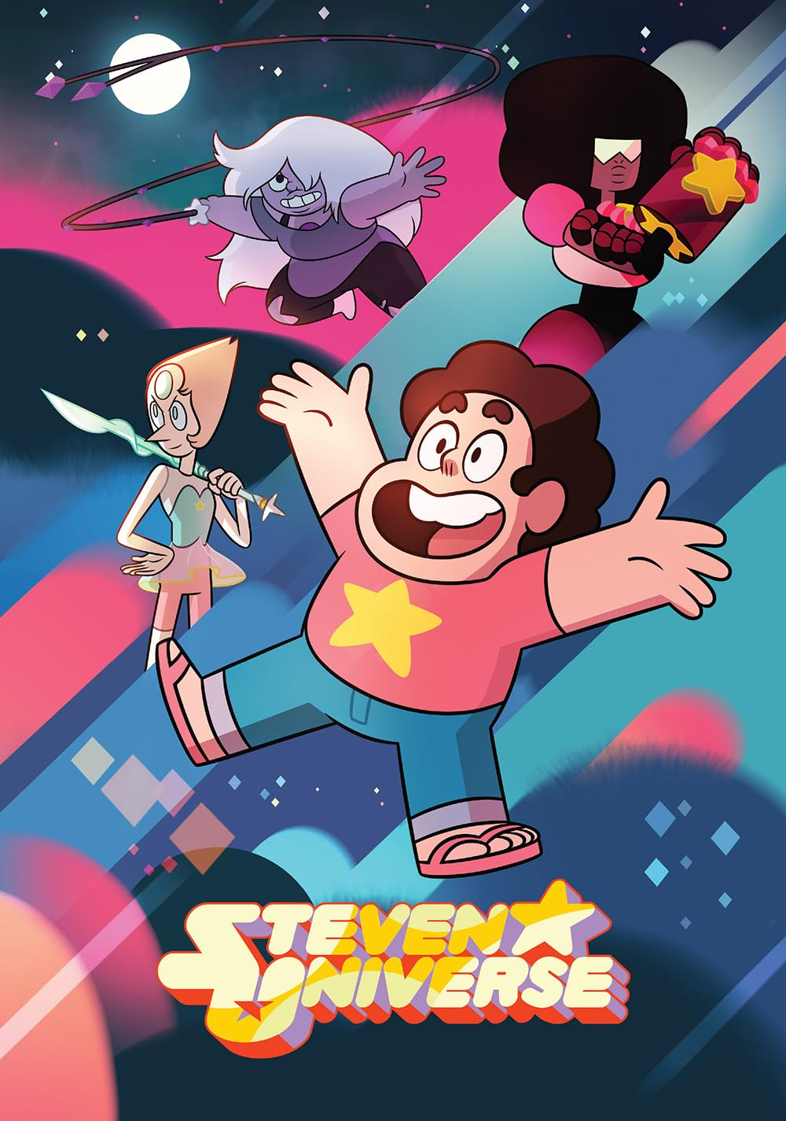

Wireframes
Home Page:

Other Pages:

